HI All
Trout season closes this month, you do get one extra day, so it will not be long before opening day and the schoolies return.
I have been busy tying and have almost finished my donation of a box of salt water flyes for the TU 224 April 4th banquet. The club members have tied over 104 flyes to be put into two boxes, for the Stripers Forever Auction (date to be announced), over 52 flyes for the RICAN food pantry auction, and have donated a UFTRI fly box full of fresh water flyes to the TU banquet. The club members are continuing the tradition of helping the community. Keep an eye out for more volunteer opportunities at Addieville East Farm, the Cinder Worm Workshop, Aquatics Education Division programs, Dare to Dream Ranch, and more.
The March meeting was attended by about 33 members.
Thanks to the tyers: Glen Northrup, Russ Ahlgren, Scott Travers, Mike Lombardo, Ron Marafioti, and Peter Burgess.
I have no news on Roger, so if someone has talked with him let the club know, thanks.
There were winners for the buckets, but I cannot find my notes, sorry.
We will be asking for nominations for the Executive Board and for the Board Members at Large.
The openings are President, VP, Web Master, Education Director, and openings on the Board. Consider it, has the others and myself have found it rewarding. Thanks in advance.

This month’s tyers are:
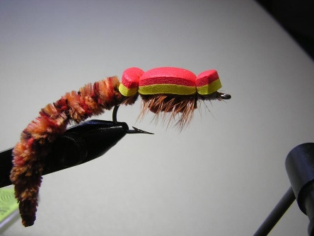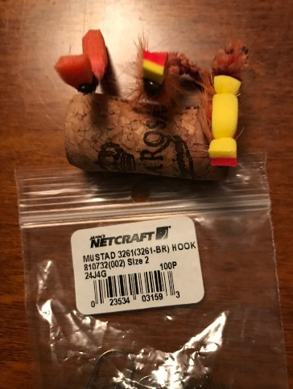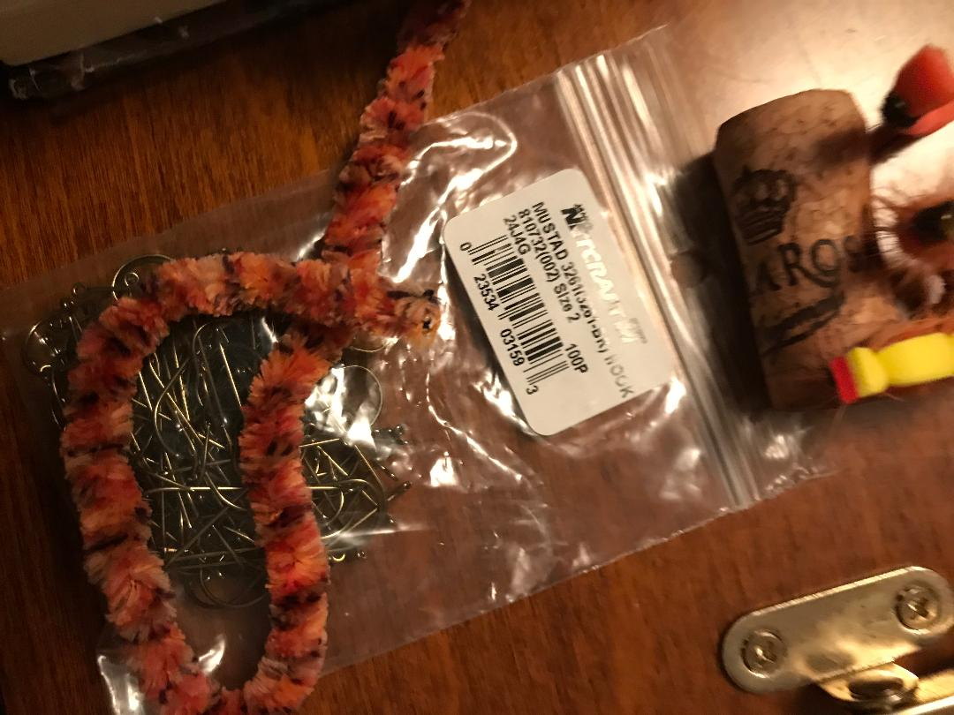
Table 1 Worm Fly Wes Wyatts
THREAD : 3/0 FLAT WAXED MONOCORD
HOOK : MUSTAD 3261 SIZE 2 LIGHT WIRE WORM HOOK
TAIL : PATONS BOHEMIAN YARN ORANGE AND BLACK VARIEGATED
BODY : SAME MATERIAL AS TAIL
RIBBING : FINE GOLD WIRE
HACKLE : ORANGE SADDLE HACKLE
THROAT : PEACOCK HURL
CLOSED CELL FOAM TIED OVER LENGTH OF ENTIRE FLY
TYING INSTRUCTIONS
1: PUT THE HOOK IN THE VISE AND WIND TO BEND OF HOOK SHANK
2: BURN THE END OF TAIL MATERIAL TO MAKE A SMALL TAPERED END. TIE IN
TAIL MATERIAL ABOUT LENGTH OF HOOK SHANK
3: TIE IN RIBBING AND BODY MATERIAL WIND BODY MATERIAL ALL THE WAY UP
THE HOOK SHANK LEAVING ENOUGH ROOM TO TIE IN PEACOCK HURL
4: TIE IN ORANGE HACKLE BY THE BOTTOM OF THE STEM REMOVE SOME FLUFF
LEAVING A LITTLE. WIND HACKLE TO BEND OF HOOK HOLDING IT THERE AND
BRINGING UP THE WIRE RIBBING LOCKING IN THE FEATHER. WORKING IN THE
WIRE AS TO NOT CATCH ANY OF THE FEATHER FIBERS. TIE IN PEACOCK HURL MAKE
A FEW WRAPS WHIP FINISH AND CUT THREAD. NOW TAKE CLOSED CELL FOAM AND
CUT TWO PIECES EXACT LENGTH AND WIDTH AND SHAPE TIE IN FRONT WHIP FINISH
AND THEN TIE IN BACK AND WHIP FINISH. I USE A TOP COLOR (YELLOW ) FOR
THE FOAM THAT WILL SHOW ON TOP OF THE WATER 90 FEET OUT
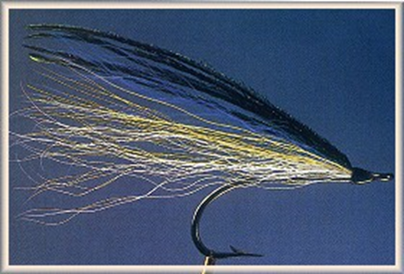
Table 2 3 Feather Flatwing Silver Outcast Steve Cook
Ultra-thread, white... #70
3/0 Eagle Claw 254 hook
White bucktail supporting
white neck feather, tied curving up
under a white saddle, tied curve down
then three strands of purple mirage tinsel
then a yellow saddle feather, curve down
the three strands of purple mirage foil
Purple saddle, tied curve down
All collected under pearl Bill's Body Braid
Yellow bucktail wings
Purple bucktail over top
white bucktail or calf tail throat
Jungle Cock eyes
Peacock heel optional

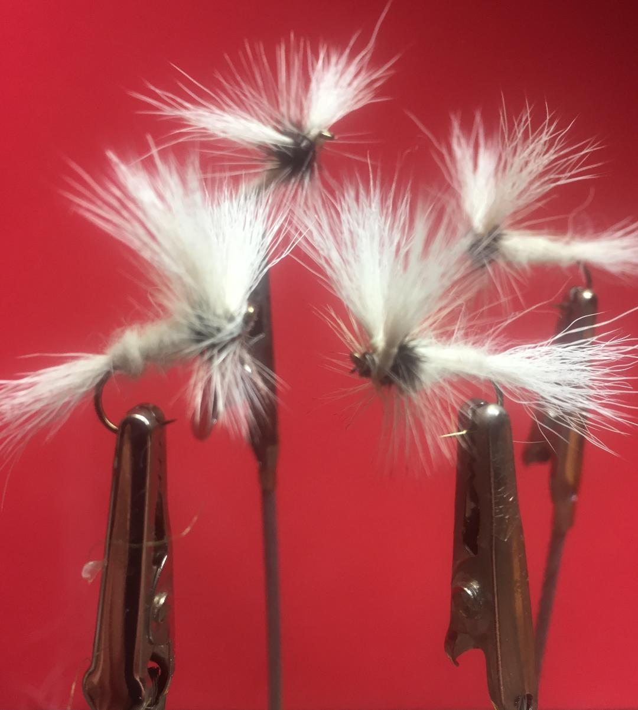

Table 3 White Wulff Jeff Perry
Hook: Dry Fly hook #10-#18
Thread: White 8/0 thread
Tail: White calf body hair
Wing: White calf body hair
Body: White dubbing
Hackle: Silver badger hackle
Head: White
“The Wulff flies were designed by Lee Wulff to fill a decided need in large sizes. I consider them necessary to the well-balanced fly box. — Ray Bergman, Trout (1952)
I have great success with this fly for small mouth bass in Maine. I believe it imitates dragon flyes, drakes and damsel flyes. I would also say it could be used a hex fly in our local waters, because of its size.

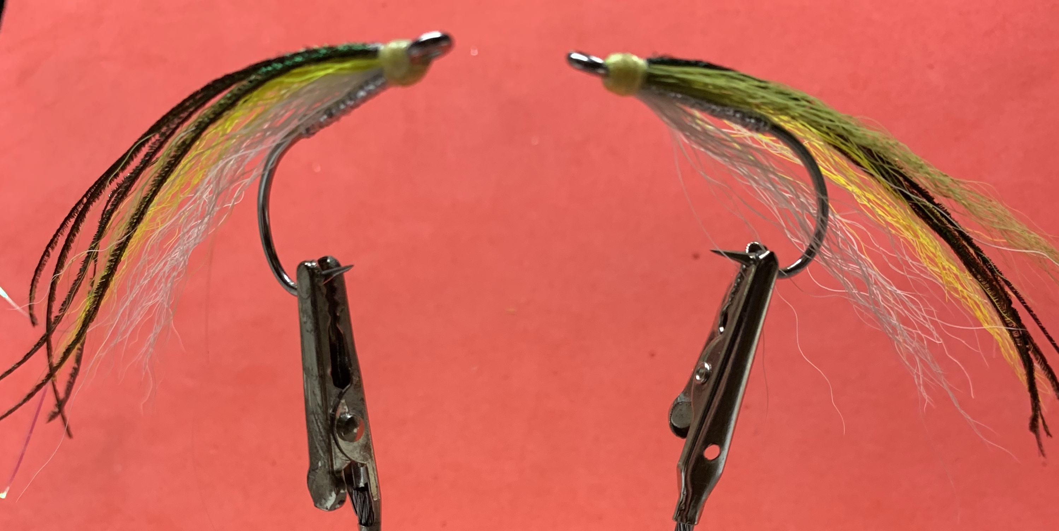

Table 4 Ray’s Fly Dave Pollack
Hook: 2/0-4/0
Thread: Monocord, light green or pale yellow
Body: Bill’s Body Braid or tinsel yarn, silver
Wing: A small bunch of white bucktail over which is tied two strands of pearl flashabou, a smaller bunch of light yellow bucktail, tow strands of pearl flashabou topped by a still smaller bunch of olive bucktail. (You can substitute silver flashabou the pearl if you prefer more flash.
Topping: Four to five strands of peacock herl
This Ray Bondorew fly originates from the shoreline of Narragansett. It has the colorations of the silverside and can be tied sparsely to imitate a sand eel. The length is two to six inches.
Alex Petti of Fin and Feather (salt water)
Scott Travers of the RIDEM Aquatics Education Division and famous mop fly guy (fresh water)
Irish Joke of the Month:
It was raining hard and a big puddle had formed in front of an Irish pub. An old man stood beside the puddle holding a stick with a string on the end and jiggled it up and down in the water.
A curious gentleman asked what he was doing.
'Fishing,' replied the old man.
'Poor old fool' thought the gentleman, so he invited the old man to have a drink in the pub.

Feeling he should start some conversation while they were sipping their whiskey, the gentleman asked, And how many have you caught?'
'You're the eighth.'
Happy St. Patrick’s Day.
Keep an eye out on the weather, we are getting close to being out to the woods, and into the woods.
See you March 4th.
Thanks

